IOT Heart Attack Detection & Heart Rate Monitor

These days we have an increased number of heart diseases including increased risk of heart attacks. Our proposed system users sensors that allow to detect heart rate of a person using heartbeat sensing even if the person is at home. The sensor is then interfaced to a microcontroller that allows checking heart rate readings and transmitting them over internet. The user may set the high as well as low levels of heart beat limit. After setting these limits, the system starts monitoring and as soon as patient heart beat goes above a certain limit, the system sends an alert to the controller which then transmits this over the internet and alerts the doctors as well as concerned users. Also the system alerts for lower heartbeats. Whenever the user logs on for monitoring, the system also displays the live heart rate of the patient. Thus concerned ones may monitor heart rate as well get an alert of heart attack to the patient immediately from anywhere and the person can be saved on time.

Block Diagram:

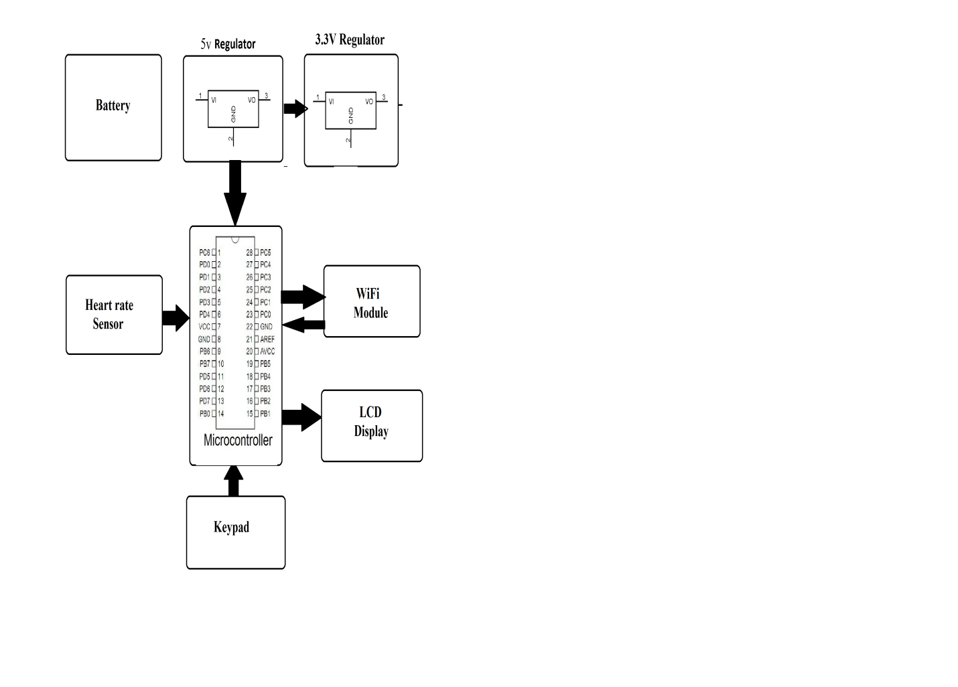

Hardware Specifications:
- Heart Beat Sensor
- Atmega 328 Microcontroller
- Wi-Fi Modem
- LCD Display
- LED’s
- Transformer
- Resistors
- Capacitors
- Diodes
Software Specifications:
- Arduino Compiler
- MC Programming Language: C
- IOTGecko

Reference
- http://ieeexplore.ieee.org/xpl/articleDetails.jsp?arnumber=7454565&newsearch=true&queryText=iot%20health

- http://ieeexplore.ieee.org/xpl/articleDetails.jsp?arnumber=7454565&newsearch=true&queryText=iot%20health

